**Lab 06**

**21k-3881**

**Task 01**

**.java**

import java.io.IOException;

import jakarta.servlet.ServletException;

import jakarta.servlet.http.Cookie;

import jakarta.servlet.http.HttpServlet;

import jakarta.servlet.http.HttpServletRequest;

import jakarta.servlet.http.HttpServletResponse;

public class login_s extends HttpServlet {

@Override

protected void doPost(HttpServletRequest request, HttpServletResponse response)

throws ServletException, IOException {

String u_na=request.getParameter("u_na");

String pa=request.getParameter("pa");

if ("taha".equals(u_na) && "abc".equals(pa)) {

Cookie Us=new Cookie("user", "authenticated");

Us.setMaxAge(60*60);

response.addCookie(Us);

response.getWriter().println("successfully login!!!"); }

else {

response.getWriter().println("failed to login!!!");

}

}

}

**.html**

<!DOCTYPE html>

<html>

<head>

</head>

<body>

<form action="login_s" method="post">

<label for="u_na">USERNAME = </label>

<input type="text" id="u_na" name="u_na">

<label for="pa">PASSWORD = </label>

<input type="password" id="pa" name="pa"><br><br>

<button class="Login">LOGIN</button>

</form>

</body>

</html>

**.xml**

<?xml version="1.0" encoding="UTF-8"?>

<web-app version="6.0" xmlns="https://jakarta.ee/xml/ns/jakartaee" xmlns:xsi="http://www.w3.org/2001/XMLSchema-instance" xsi:schemaLocation="https://jakarta.ee/xml/ns/jakartaee https://jakarta.ee/xml/ns/jakartaee/web-app_6_0.xsd">

<servlet>

<servlet-name>login_s</servlet-name>

<servlet-class>login_s</servlet-class>

</servlet>

<servlet-mapping>

<servlet-name>login_s</servlet-name>

<url-pattern>/login_s</url-pattern>

</servlet-mapping>

<session-config>

<session-timeout>

30

</session-timeout>

</session-config>

</web-app>

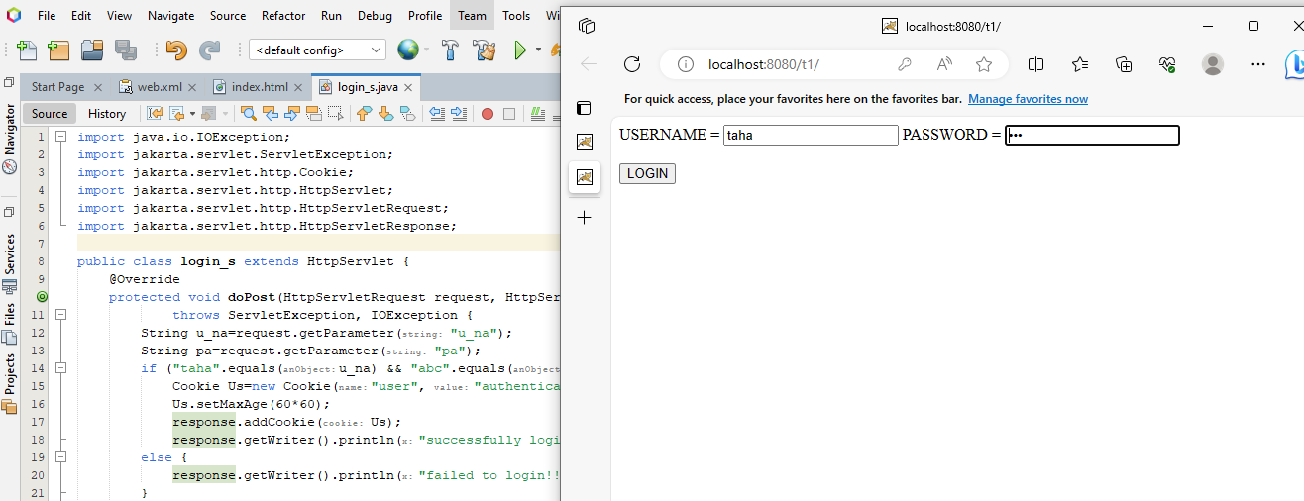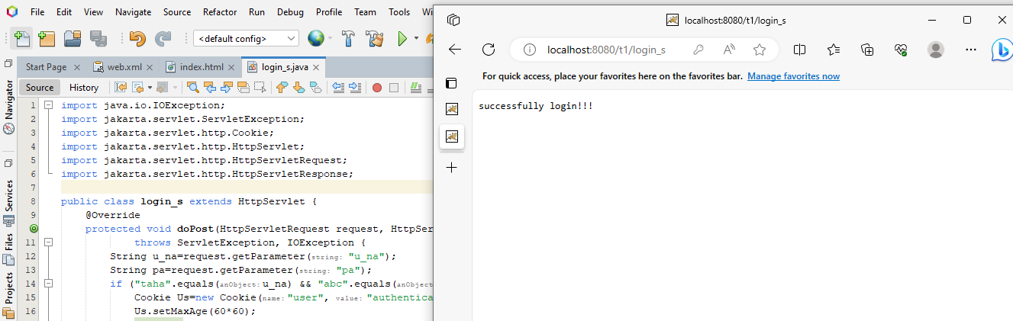

**Task 02**

**.java**

import java.io.IOException;

import java.io.PrintWriter;

import java.util.UUID;

import jakarta.servlet.ServletException;

import jakarta.servlet.http.Cookie;

import jakarta.servlet.http.HttpServlet;

import jakarta.servlet.http.HttpServletRequest;

import jakarta.servlet.http.HttpServletResponse;

public class cr_servlet extends HttpServlet {

@Override

protected void doGet(HttpServletRequest request, HttpServletResponse response)

throws ServletException, IOException {

response.setContentType("text/html");

PrintWriter out=response.getWriter();

String co_n="Cookies";

Cookie[] c=request.getCookies();

if(c!=null){

for(Cookie co:c){

if (co.getName().equals(co_n)) {

String c_val=co.getValue();

out.println(co_n+" = "+" "+c_val);

return; }

} }

String uc=UUID.randomUUID().toString();

Cookie ucc=new Cookie(co_n, uc);

ucc.setMaxAge(60*60);

response.addCookie(ucc);

out.println("Cookies = " + co_n+ " "+uc);

}

}

**.html**

<!DOCTYPE html>

<html>

<head>

</head>

<body>

<p>Click for cookie!!!</p>

<form action="cr_servlet" method="get">

<input type="submit" value="CLICK">

</form>

</body>

</html>

**.xml**

<?xml version="1.0" encoding="UTF-8"?>

<web-app version="6.0" xmlns="https://jakarta.ee/xml/ns/jakartaee" xmlns:xsi="http://www.w3.org/2001/XMLSchema-instance" xsi:schemaLocation="https://jakarta.ee/xml/ns/jakartaee https://jakarta.ee/xml/ns/jakartaee/web-app_6_0.xsd">

<servlet>

<servlet-name>cr_servlet</servlet-name>

<servlet-class>cr_servlet</servlet-class>

</servlet>

<servlet-mapping>

<servlet-name>cr_servlet</servlet-name>

<url-pattern>/cr_servlet</url-pattern>

</servlet-mapping>

<session-config>

<session-timeout>

30

</session-timeout>

</session-config>

</web-app>

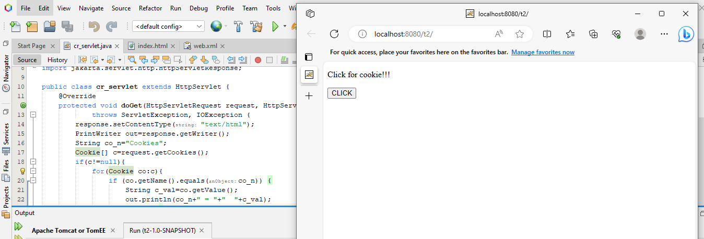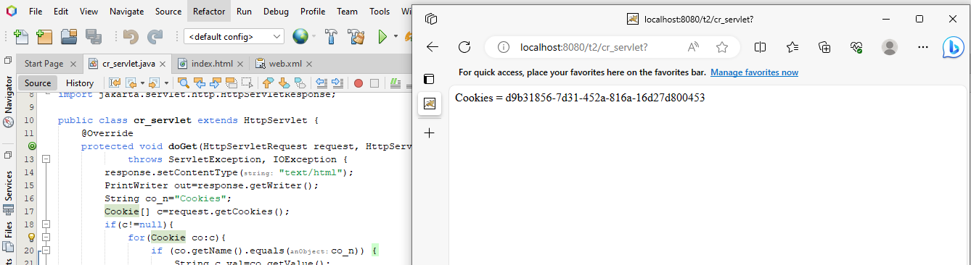

**Task 03**

**.java**

import java.io.IOException;

import java.io.PrintWriter;

import jakarta.servlet.*;

import jakarta.servlet.http.*;

public class login_s extends HttpServlet {

@Override

protected void doPost(HttpServletRequest request, HttpServletResponse response)

throws ServletException, IOException {

response.setContentType("text/html");

PrintWriter out=response.getWriter();

String un=request.getParameter("un");

String pw=request.getParameter("pw");

boolean rm="on".equals(request.getParameter("rm"));

if (rm){

Cookie uc=new Cookie ("rememberedUsername",un);

Cookie pc=new Cookie ("rememberedPassword",pw);

uc.setMaxAge(7*24*60*60);

pc.setMaxAge(7*24*60*60);

response.addCookie(uc);

response.addCookie(pc); }

else {

out.println("Login failed!!!");

}

response.sendRedirect("welcome.jsp"); }

}

**.html**

<!DOCTYPE html>

<html>

<head>

</head>

<body>

<form action="login_s" method="post">

<label for="u_na">USERNAME = </label>

<input type="text" id="u_na" name="u_na">

<label for="pass">PASSWORD = </label>

<input type="password" id="pass" name="pass">

<label for="r">REMEMBER</label>

<input type="checkbox" id="r" name="r">

<button class="Login">CLICK</button>

</form>

</body>

</html>

**Jsp**

<!DOCTYPE html>

<html>

<head>

<title>Welcome Page</title>

</head>

<body>

<h1>HELLO,THIS IS TAHA JAWAID PRESENTING YOU !!!</h1>

</body>

</html>

**.xml**

<?xml version="1.0" encoding="UTF-8"?>

<web-app version="6.0" xmlns="https://jakarta.ee/xml/ns/jakartaee" xmlns:xsi="http://www.w3.org/2001/XMLSchema-instance" xsi:schemaLocation="https://jakarta.ee/xml/ns/jakartaee https://jakarta.ee/xml/ns/jakartaee/web-app_6_0.xsd">

<servlet>

<servlet-name>login_s</servlet-name>

<servlet-class>login_s</servlet-class>

</servlet>

<servlet-mapping>

<servlet-name>login_s</servlet-name>

<url-pattern>/login_s</url-pattern>

</servlet-mapping>

<session-config>

<session-timeout>

30

</session-timeout>

</session-config>

</web-app>

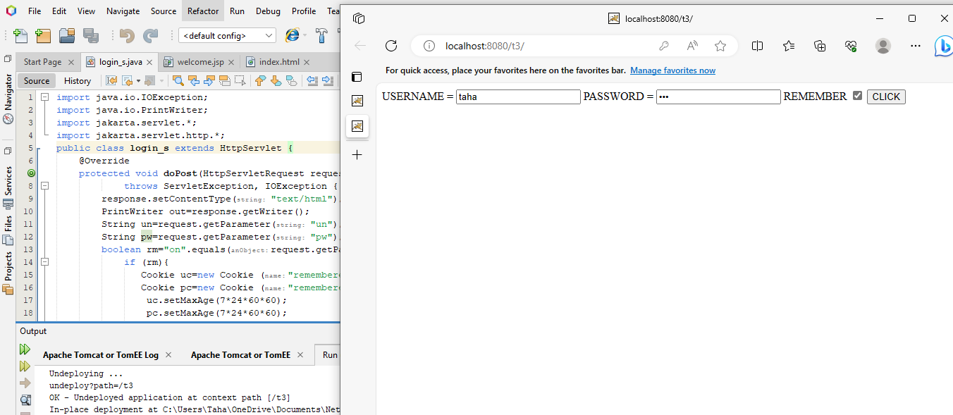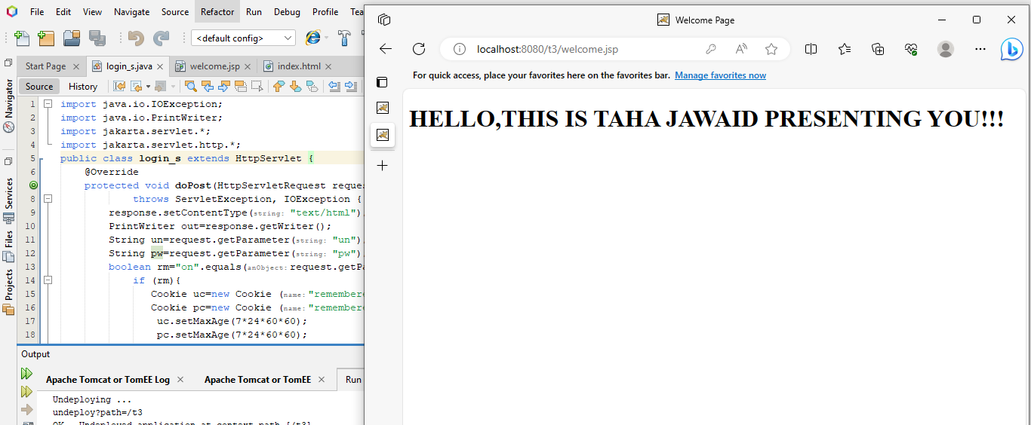

**Task 04**

**.java**

import java.io.IOException;

import jakarta.servlet.ServletException;

import jakarta.servlet.http.Cookie;

import jakarta.servlet.http.HttpServlet;

import jakarta.servlet.http.HttpServletRequest;

import jakarta.servlet.http.HttpServletResponse;

public class sc_servlet extends HttpServlet {

protected void doPost(HttpServletRequest request, HttpServletResponse response)

throws ServletException, IOException {

String i_na=request.getParameter("i_na");

double i_p=Double.parseDouble(request.getParameter("i_p"));

Cookie c[]=request.getCookies();

Cookie cc=findCookie(c, "cart");

String cco=(cc!= null)? cc.getValue(): "";

String[] ci=cco.split(";");

boolean iex=false;

for (String cit : ci) {

String itd[]=cit.split(":");

if (itd[0].equals(i_na)) {

int q=Integer.parseInt(itd[1])+1;

cit=i_na+ ":"+q;

iex=true;

break; }

}

if (!iex){

cco+=(cco.isEmpty() ? "" : ";")+i_na+":1"; }

Cookie ucc= new Cookie("cart", cco);

response.addCookie(ucc);

response.sendRedirect("index.html");

}

private Cookie findCookie(Cookie coo[], String n){

if(coo!= null) {

for (Cookie cook : coo) {

if (cook.getName().equals(n)){

return cook; }

}

}

return null;

}

}

**.html**

<!DOCTYPE html>

<html lang="en">

<head>

<meta charset="UTF-8">

<meta name="viewport" content="width=device-width, initial-scale=1.0">

</head>

<body>

<form action="sc_servlet" method="post">

<label for="in">PRODUC NAME = </label>

<input type="text" id="in" name="in" required>

<label for="ip">PRODUCT COST = </label>

<input type="number" id="ip" name="ip" required>

<input type="submit" value="Add Cart">

</form>

<script>

function getCookie(name) {

const cookies = document.cookie.split(';');

const cookie = cookies.find(c => c.trim().startsWith(name + '='));

return cookie ? cookie.split('=')[1] : null;

}

function updateCartDisplay() {

const cartContent = getCookie('cart');

const cartContainer = document.getElementById('cart');

if (cartContent) {

const items = cartContent.split(';');

cartContainer.innerHTML = '<ul>';

items.forEach(item => {

const [itemName, quantity] = item.split(':');

cartContainer.innerHTML += `<li>${itemName}: ${quantity}</li>`;

});

cartContainer.innerHTML += '</ul>';

} else {

cartContainer.innerHTML = '<p>Your cart is empty.</p>';

}

}

updateCartDisplay();

</script>

</body>

</html>

**.xml**

<?xml version="1.0" encoding="UTF-8"?>

<web-app version="6.0" xmlns="https://jakarta.ee/xml/ns/jakartaee" xmlns:xsi="http://www.w3.org/2001/XMLSchema-instance" xsi:schemaLocation="https://jakarta.ee/xml/ns/jakartaee https://jakarta.ee/xml/ns/jakartaee/web-app_6_0.xsd">

<servlet>

<servlet-name>sc_servlet</servlet-name>

<servlet-class>sc_servlet</servlet-class>

</servlet>

<servlet-mapping>

<servlet-name>sc_servlet</servlet-name>

<url-pattern>/sc_servlet</url-pattern>

</servlet-mapping>

<session-config>

<session-timeout>

30

</session-timeout>

</session-config>

</web-app>

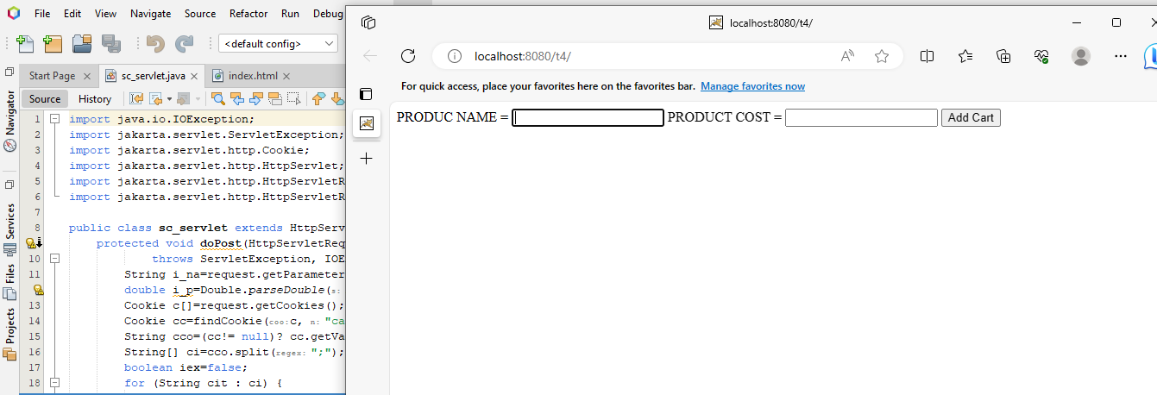

**Task 05**

**.java**

import jakarta.servlet.*;

import jakarta.servlet.http.*;

import java.io.IOException;

import java.io.PrintWriter;

public class http_post extends HttpServlet{

public void doPost(HttpServletRequest req, HttpServletResponse res)

throws ServletException, IOException {

res.setContentType("text/html");

PrintWriter out=res.getWriter();

String n=req.getParameter("user_name");

String e=req.getParameter("email");

String c=req.getParameter("user_course");

String co=req.getParameter("condition");

if(co!=null){

if(co.equals("checked")){

out.println("NAME = "+n);

out.println(" ,,, EMAIL = "+e);

out.println(" ,,, COURSE = "+c);

out.println(" ,,, "+co); }

else{

out.println("you do not accept condition"); }

}

else{

out.println("you do not accept condition"); }

}

}

**.html**

<html>

<head>

<meta charset="UTF-8">

<meta name="viewport" content="width=device-width, initial-scale=1.0">

</head>

<body>

<form id="myform" action="http_post" method="post">

<table>

<tr>

<td>NAME</td>

<td><input type="text" name="user_name"></td>

</tr>

<tr>

<td>EMAIL</td>

<td><input type="email" name="email"></td>

</tr>

<tr>

<td>COURSE</td>

<td>

<select name="user_course">

<option value="C">C</option>

<option value="SQL">SQL</option>

<option value="C++">C++</option>

</select>

</td>

</tr>

<tr>

<td>

<input type="checkbox" value="checked" name="condition">

</td>

<td>

Conditions

</td>

</tr>

<tr>

<td>

<button type="submit">SUBMIT</button>

</td>

</tr>

</table>

</form>

</body>

</html>

**.xml**

<?xml version="1.0" encoding="UTF-8"?>

<web-app version="6.0" xmlns="https://jakarta.ee/xml/ns/jakartaee" xmlns:xsi="http://www.w3.org/2001/XMLSchema-instance" xsi:schemaLocation="https://jakarta.ee/xml/ns/jakartaee https://jakarta.ee/xml/ns/jakartaee/web-app_6_0.xsd">

<servlet>

<servlet-name>t5</servlet-name>

<servlet-class>t5</servlet-class>

</servlet>

<servlet>

<servlet-name>http_post</servlet-name>

<servlet-class>http_post</servlet-class>

</servlet>

<servlet-mapping>

<servlet-name>t5</servlet-name>

<url-pattern>/t5</url-pattern>

</servlet-mapping>

<servlet-mapping>

<servlet-name>http_post</servlet-name>

<url-pattern>/http_post</url-pattern>

</servlet-mapping>

<session-config>

<session-timeout>

30

</session-timeout>

</session-config>

</web-app>

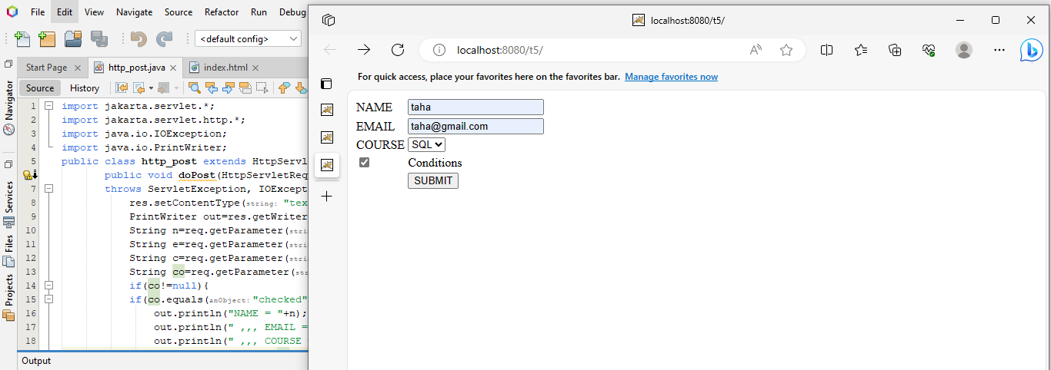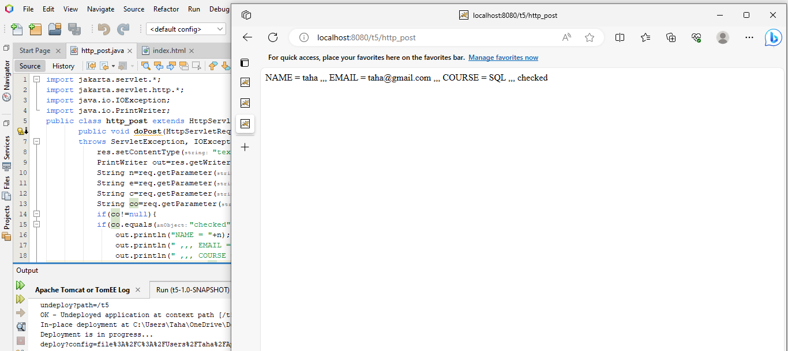

**Task 06**

**.java**

import java.io.IOException;

import jakarta.servlet.ServletException;

import jakarta.servlet.http.HttpServlet;

import jakarta.servlet.http.HttpServletRequest;

import jakarta.servlet.http.HttpServletResponse;

public class httpStatus extends HttpServlet {

protected void doGet(HttpServletRequest request, HttpServletResponse response)

throws ServletException, IOException {

String s=request.getParameter("status");

if(s==null||s.isEmpty()){

response.setStatus(HttpServletResponse.SC_OK);

response.getWriter().write("This is a default response (200 OK)."); }

else if(s.equals("404")) {

response.setStatus(HttpServletResponse.SC_NOT_FOUND);

response.getWriter().write("404 - Not Found"); }

else if(s.equals("500")) {

response.setStatus(HttpServletResponse.SC_INTERNAL_SERVER_ERROR);

response.getWriter().write("500 - Internal Server Error"); }

}

}

**.html**

<html>

<head>

</head>

<body>

<p>press below to trigger different http status codes</p>

<form action="httpStatus" method="GET">

<input type="submit" name="s" value="Default error">

<input type="submit" name="s" value="404 Not Found">

<input type="submit" name="s" value="500 Internal Server Error">

</form>

</body>

</html>

**.xml**

<?xml version="1.0" encoding="UTF-8"?>

<web-app version="6.0" xmlns="https://jakarta.ee/xml/ns/jakartaee" xmlns:xsi="http://www.w3.org/2001/XMLSchema-instance" xsi:schemaLocation="https://jakarta.ee/xml/ns/jakartaee https://jakarta.ee/xml/ns/jakartaee/web-app_6_0.xsd">

<servlet>

<servlet-name>httpStatus</servlet-name>

<servlet-class>httpStatus</servlet-class>

</servlet>

<servlet-mapping>

<servlet-name>httpStatus</servlet-name>

<url-pattern>/httpStatus</url-pattern>

</servlet-mapping>

<session-config>

<session-timeout>

30

</session-timeout>

</session-config>

</web-app>

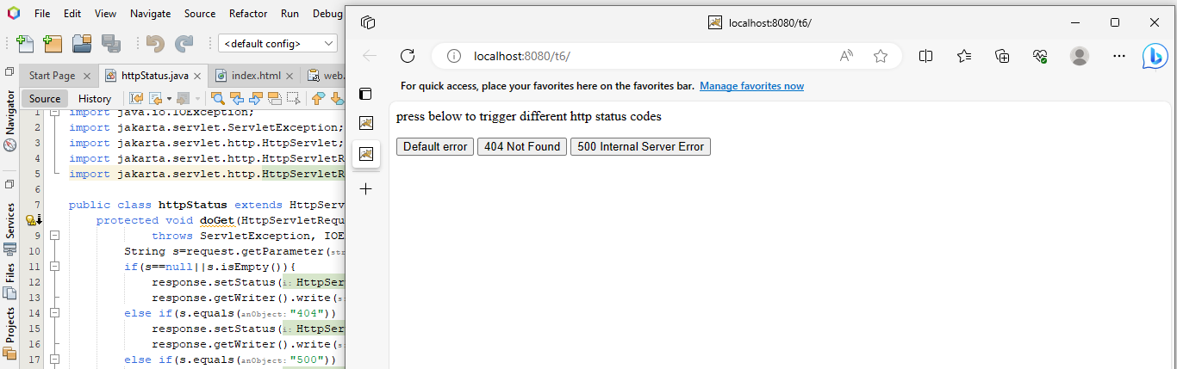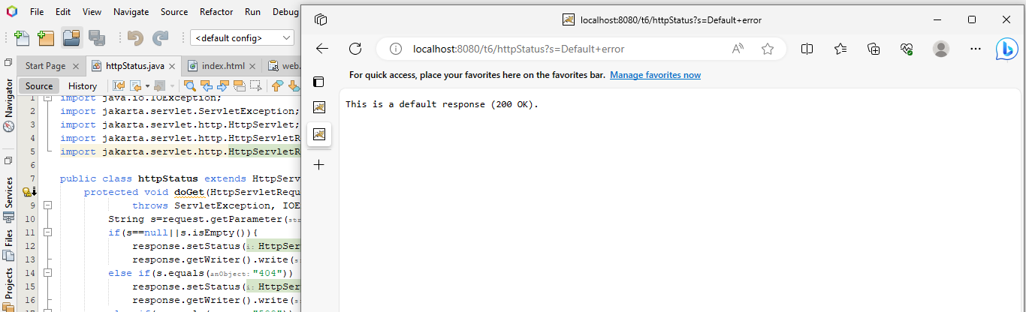

**Task 07**

**.java**

**Sa**

import java.io.IOException;

import java.io.PrintWriter;

import jakarta.servlet.ServletException;

import jakarta.servlet.http.Cookie;

import jakarta.servlet.http.HttpServlet;

import jakarta.servlet.http.HttpServletRequest;

import jakarta.servlet.http.HttpServletResponse;

public class sa extends HttpServlet {

protected void processRequest(HttpServletRequest request, HttpServletResponse response)

throws ServletException, IOException {

response.setContentType("text/html;charset=UTF-8");

try (PrintWriter out=response.getWriter()) {

out.println("<!DOCTYPE html>");

out.println("<html>");

out.println("<head>");

out.println("</head>");

out.println("<body>");

out.println("Stores ID servelet b");

String userid=request.getParameter("user_id");

out.println("<a href='sb'>for servlet b</a>");

Cookie c = new Cookie("userid",userid);

response.addCookie(c);

out.println("</body>");

out.println("</html>");

}

}

}

**Sb**

import java.io.IOException;

import java.io.PrintWriter;

import jakarta.servlet.ServletException;

import jakarta.servlet.http.Cookie;

import jakarta.servlet.http.HttpServlet;

import jakarta.servlet.http.HttpServletRequest;

import jakarta.servlet.http.HttpServletResponse;

public class sb extends HttpServlet {

protected void processRequest(HttpServletRequest request, HttpServletResponse response)

throws ServletException, IOException {

response.setContentType("text/html;charset=UTF-8");

try (PrintWriter out=response.getWriter()) {

out.println("<!DOCTYPE html>");

out.println("<html>");

out.println("<head>");

out.println("</head>");

out.println("<body>");

Cookie cook[]=request.getCookies();

boolean f=false;

String id="";

if(cook==null){

out.println("You are new user go to home page and submit your id</");

return; }

else {

for(Cookie c:cook){

String t=c.getName();

if(t.equals("userid")){

f=true;

id=c.getValue(); }

}

}

out.println();

if(f){

out.println("ID = "+id);}

else{

out.println("<You are new user go to home page and submit your id"); }

out.println("</body>");

out.println("</html>");

}

}

}

**.html**

<!DOCTYPE html>

<html>

<head>

<meta charset="UTF-8">

<meta name="viewport" content="width=device-width, initial-scale=1.0">

</head>

<body>

<form action="sa">

<input type="text" name="id">

<button type="submit">press 1st servlet</button>

</form>

</body>

</html>

**.xml**

<?xml version="1.0" encoding="UTF-8"?>

<web-app version="6.0" xmlns="https://jakarta.ee/xml/ns/jakartaee" xmlns:xsi="http://www.w3.org/2001/XMLSchema-instance" xsi:schemaLocation="https://jakarta.ee/xml/ns/jakartaee https://jakarta.ee/xml/ns/jakartaee/web-app_6_0.xsd">

<servlet>

<servlet-name>sa</servlet-name>

<servlet-class>sa</servlet-class>

</servlet>

<servlet>

<servlet-name>sb</servlet-name>

<servlet-class>sb</servlet-class>

</servlet>

<servlet-mapping>

<servlet-name>sa</servlet-name>

<url-pattern>/sa</url-pattern>

</servlet-mapping>

<servlet-mapping>

<servlet-name>sb</servlet-name>

<url-pattern>/sb</url-pattern>

</servlet-mapping>

<session-config>

<session-timeout>

30

</session-timeout>

</session-config>

</web-app>

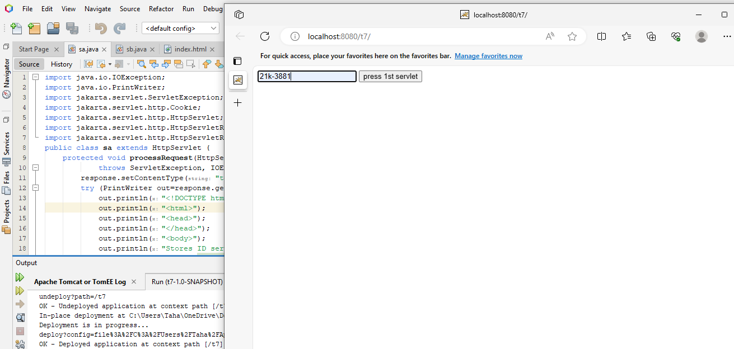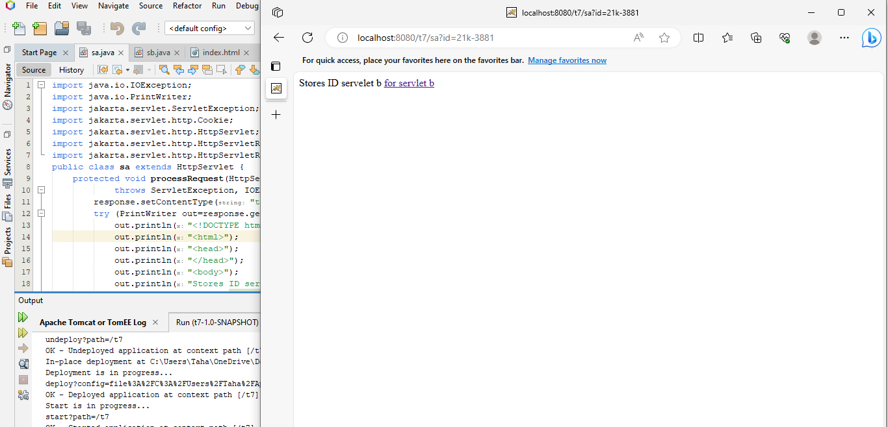

**Task 08**

**.java**

` import java.io.IOException;

import jakarta.servlet.ServletException;

import jakarta.servlet.http.HttpServlet;

import jakarta.servlet.http.HttpServletRequest;

import jakarta.servlet.http.HttpServletResponse;

public class ss extends HttpServlet {

protected void doPost(HttpServletRequest request, HttpServletResponse response)

throws ServletException, IOException {

String s=request.getParameter("step");

if ("1".equals(s)) {

String d1=request.getParameter("dataStep1");

request.setAttribute("dataStep1", d1);

request.getRequestDispatcher("a.html").forward(request, response); }

else if ("2".equals(s)){

String d2=request.getParameter("dataStep2");

request.setAttribute("dataStep2", d2);

request.getRequestDispatcher("wel.html").forward(request, response); }

}

}

**index.html**

<!DOCTYPE html>

<html lang="en">

<head>

<meta charset="UTF-8">

<meta name="viewport" content="width=device-width, initial-scale=1.0">

</head>

<body>

<form action="ss" method="post">

<input type="hidden" name="step" value="1">

<label for="dataStep1">Enter data 1</label>

<input type="text" id="dataStep1" name="dataStep1" required>

<button type="submit">Next</button>

</form>

</body>

</html>

**Wel.html**

<!DOCTYPE html>

<html lang="en">

<head>

<meta charset="UTF-8">

<meta name="viewport" content="width=device-width, initial-scale=1.0">

</head>

<body>

<p>data 1 {data1}</p>

<p>data 2 {data2}</p>

</body>

</html>

**a.html**

<!DOCTYPE html>

<html lang="en">

<head>

<meta charset="UTF-8">

<meta name="viewport" content="width=device-width, initial-scale=1.0">

</head>

<body>

<form action="ss" method="post">

<input type="hidden" name="step" value="2">

<label for="dataStep2">Enter data 2</label>

<input type="text" id="dataStep2" name="dataStep2" required>

<button type="submit">Next</button>

</form>

</body>

</html>

**.xml**

<?xml version="1.0" encoding="UTF-8"?>

<web-app version="6.0" xmlns="https://jakarta.ee/xml/ns/jakartaee" xmlns:xsi="http://www.w3.org/2001/XMLSchema-instance" xsi:schemaLocation="https://jakarta.ee/xml/ns/jakartaee https://jakarta.ee/xml/ns/jakartaee/web-app_6_0.xsd">

<servlet>

<servlet-name>ss</servlet-name>

<servlet-class>ss</servlet-class>

</servlet>

<servlet-mapping>

<servlet-name>ss</servlet-name>

<url-pattern>/ss</url-pattern>

</servlet-mapping>

<session-config>

<session-timeout>

30

</session-timeout>

</session-config>

</web-app>

